Name:_______________________
Period:_____ Date:____________

You decide… Feudalism: Good or Bad?
Feudalism was the major social and political order in medieval Europe. It developed as power passed from kings to local lords.

Good?
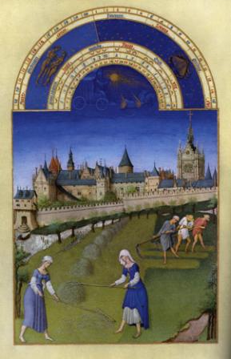
Feudalism brought together two powerful groups: lords and vassals. The lords gave vassals land in return for military and other services. Feudalism was a help to Western Europeans for the flowing reasons:
- Feudalism helped protect communities from the violence and warfare that broke out after the fall of Rome and the collapse of strong central government in Western Europe. Feudalism secured Western Europe’s society and kept out powerful invaders.
- Feudalism helped restore trade. Lords repaired bridges and roads. Their knights arrested bandits, enforced the law, and made it safe to travel on roads.
- Feudalism benefited lords, vassals, and peasants. Lords gained a dependable fighting force in their vassals. Vassals received land for their military service. Peasants were protected by their lords. The lord also built mills to grind grain and blacksmith shops and woodworking shops to make tools.
- Feudal ceremonies, oaths, and contracts required lords and vassals to be faithful and to carry out their duties to each other. These kinds of agreements and rituals later helped shape the development of western governments.
- Feudalism did not allow one person or organization to become too powerful. Power was shared among many people and groups. This was the first step to European ideas and limited government, constitutions, and civil rights.

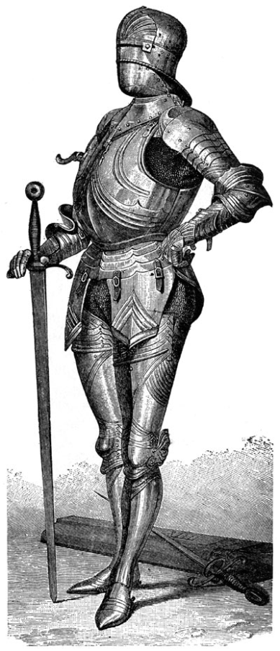
Bad?
Feudalism did not always work as well in real life as it did in theory, and it caused many problems for society.
- Feudalism provided some unity and security in local areas, but it often did not have the strength to unite larger regions or countries. Small feudal governments could not afford big projects, such as building aqueducts, sewers, or fleets of ships that might benefit society.
- Because there was no strong central government to enforce laws fairly, it was easy to use force, violence, and lies to get one’s way. This led to many wars among lords. Feudalism protected Western Europe from outside invaders, but it did not bring peace to a region.
- Lords or vassals often placed their personal interests over the interests of the areas they ruled. Feudal lords had complete power in their local areas and could make harsh demands on their vassals and peasants.
- Feudalism did not treat people equally or let them move up in society. A person born a serf was supposed to remain a serf, just as a person born a lord received special treatment without earning it.
- Most peasants were serfs. They were not allowed to leave their lord’s lands. Serfs had to work three or four days each week as a payment to the lords or vassals for allowing them to farm for themselves on other days. The serfs were restricted in movement and even daily activities because they could not leave the land without permission.

You Be the Historian (On a separate sheet of paper)
1: Do you think feudalism helped or hurt western Europe’s development?

2: Is there any way feudal lords could have worked their lands without using serfs?

3: Imagine what your life would have been if you were born into a feudal society. Write a diary entry as either a lord, vassal, or serf describing your life and your relationship with the other two groups. Your entry should show feudalism as either good or bad.

