NATIONALISM
Explain what nationalism is and what effect it can have on individuals and on society.
Describe how nationalism affected Europe in the 19th century with regards to the unification of Germany and Italy, and the weakening of the Austrian and Ottoman Empires.

What is your nationality?
_________________________________________________________________

What is nationalism? What impact can it have?
Directions: Examine the images and information presented, then answer the question that follows.
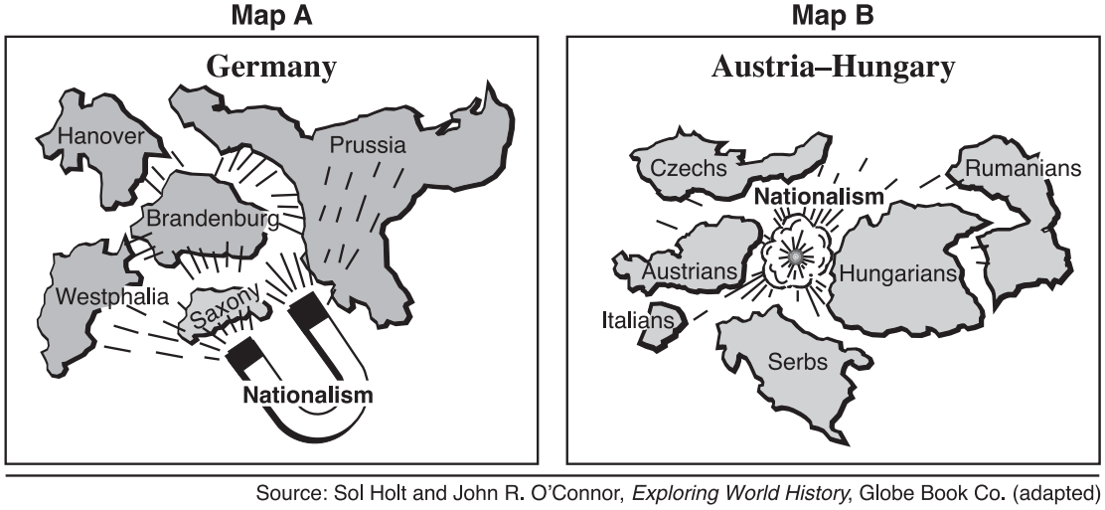
According to the authors of these two images, what effects might nationalism have on a country?
__________________________________________________________________________________
List any reasons that would result in the two different effects of nationalism?
__________________________________________________________________________________

What is a nation?
Directions: Read the definition of a nation below, then identify and explain whether the examples that follow should be considered nations.
Nation- a group of people who share a common history, culture, or language and who live in
the same area

 | 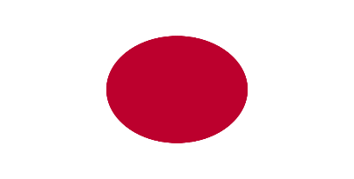 | 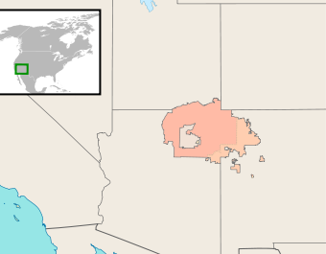
Simon loves to play video games. He is on a team that plays together online called the “Nation of Warring Wizards.” The team members are from all over the world and two of them only speak Russian but they are very good, so the rest of the team doesn’t mind that they cannot understand them.  Source: https://commons.wikimedia.org/wiki/File:TGS_2014_gamer_PC_-0880.jpg | Japan is a country in east Asia made up of a series of islands. Close to 127,000,000 people live there and 98.5% of them are of Japanese descent. Japan has a long and rich history that started with paleolithic people as early as 30,000 BCE.  Source: https://en.wikipedia.org/wiki/File:Flag_of_Japan.svg | The Navajo Nation is a semi-independent Native American-governed territory covering 27,425 square miles, occupying portions of northeastern Arizona, southeastern Utah, and northwestern New Mexico in the United States. The 250,000 residents of the Navajo Nation have Navajo ancestry and the area is governed by elected representatives.  Image Source:https://en.wikipedia.org/wiki/File:DineBikeyahBe%27elyaigii.svg
1. Should the Nation of Warring Wizards be considered a nation? Why or why not? | 2. Should Japan be considered a nation? Why or why not? | 3. Should the Navajo Nation be considered a nation? Why or why not?

What is nationalism?
Nationalism- strong feelings of support for one’s nation

Image A | Image B | Image C
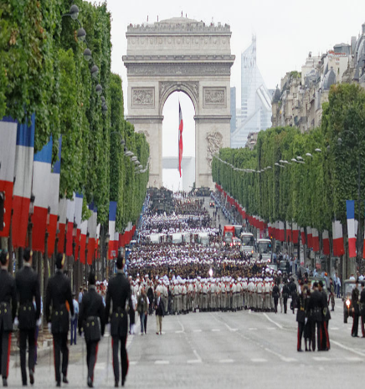 | 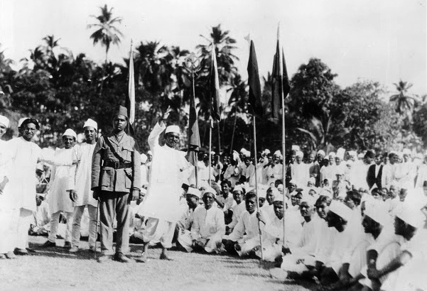 | 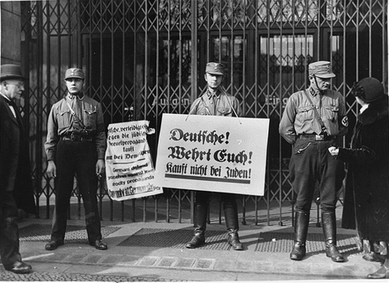
The French celebrate Bastille Day every year on July 14th to mark the start of the French Revolution and honor their history of government based on Enlightenment ideals. | In the 1930s, Indian nationalists protested against British rule. Led by Mohandas Gandhi, they used non-violent tactics to gain independence for India. | In the 1930s, nationalism in Germany was fueled by blaming the country’s problems on Jewish people. In this photo, German soldiers hold signs reading “Germans! Defend yourselves! Don’t buy from Jews!”
What do you see happening in this image?  Explain why this image depicts an example of nationalism. | What do you see happening in this image?  Explain why this image depicts an example of nationalism. | What do you see happening in this image?  Explain why this image depicts an example of nationalism.

What effect did nationalism have on Europe in the 19th century?
Napoleon on European Nationalist Movements

The French Revolution (1789–1799) was a period of political and social upheaval in France and Europe, during which the French government, previously an absolute monarchy, underwent radical changes based on Enlightenment principles of republic, citizenship, and inalienable rights.
This revolution sparked five wars between the well-trained armies of Napoleonic France and neighbors including Prussia and Austria. From 1803 to 1814, Napoleon ruled over a large section of Europe. During that time he and the ideals of the French Revolution greatly affected the regions he controlled. The revolution’s nationalistic call for “liberty, equality, and fraternity” and a government ruled by the will of the French people, instead of a royal family with connections outside of France, inspired similar feelings in regions occupied by Napoleon’s troops. In central Europe, for example, Napoleon created the German Confederation, an association of German speaking states that were previously part of the Holy Roman Empire, Prussia, and the Austrian empire. Soon after Napoleon was defeated the German Confederation was dismantled. At the Congress of Vienna (1815) the major European powers decided to given the land back to Prussia and the Austrian Empire, but the idea of unity for German speaking people remained.
The French Revolution and Napoleon affected people living on the Italian peninsula as well. Napoleon ruled the entire area as the Napoleonic Kingdom of Italy. His reign inspired nationalistic feelings in the Italians. As happened to the German Confederation, the Kingdom of Italy was broken up after Napoleon’s defeat. The representatives at the Congress of Vienna divided Italy up into small independent governments and gave the Austrian Empire control of Northern Italy. Austrian Chancellor Franz Metternich, an influential diplomat at the Congress of Vienna, stated that the word Italy was nothing more than "a geographic expression."
Though Napoleon was defeated, the nationalism that he and the French Revolution inspired lingered in German and Italian speaking regions, threatening the Austrian Empire.

What effects did the French Revolution and Napoleon's rule have on the German and Italian speaking people in Europe?
__________________________________________________________________________________

German Unification (1861-1871)

By the mid-1800s, Prussia had been a force in politics in Northern Europe for centuries. Like most of Europe, it was conquered by Napoleon in the early 1800s and was a part of the coalition of countries who defeated him in 1814. In 1861, King Wilhelm I, a supporter of German unity, came to power. In 1862, he appointed Otto von Bismarck (1815–1898) the new Prime Minister of Prussia. Bismarck became known for his style of diplomacy known as realpolitik. Realpolitik is also known as “pragmatism” and is a way of making political decisions based on being practical instead of based on ideals. Bismarck argued that Germany could only unify through a foreign policy called “blood and iron,” meaning through war and military strength.
In 1863–64, disputes between Prussia and Denmark grew over ownership of an area called Schleswig on their borders. The dispute led to war, in the course of which Prussia, joined by Austria, defeated Denmark. Denmark was forced to give up Schleswig and another German-speaking area called Holstein. In the aftermath, the management of the two areas caused growing tensions between Austria and Prussia, which ultimately led to the Austro-Prussian War (1866). The Prussians were victorious and as a result, by 1871, Prussia, led by King Wilhelm I and Otto von Bismarck, was in control of most of the German speaking land in central Europe
King Wilhelm I and Bismarck then looked to the German-speaking lands to the west. They went to war against France in the Franco-Prussian War (1870-71). The Germans invaded Paris, captured Emperor Napoleon III, and won the war. France ceded [gave over] what became known as Alsace-Lorraine to Germany.
During the Siege of Paris, the German princes assembled in the Hall of Mirrors of the Palace of Versailles and proclaimed the Prussian King Wilhelm I as the "German Emperor" on January 18, 1871. The German Empire was thus founded, and Bismarck, again, served as Chancellor. It was dubbed the "Little German" solution, since Austria was not included. Source: “Germany.” New World Encyclopedia. http://www.newworldencyclopedia.org/entry/Germany
Questions
1. Who were the two leaders of Prussia that led the unification of Germany?

2. Describe Otto von Bismarck’s policy called realpolitik. How was realpolitik different from the way Maximilien Robespierre led during the French Revolution?

3. According to Bismarck’s “blood and iron” policy, how was Prussia going to unite the German-speaking people?

4. Which countries did Prussia go to war with to gain control of the German speaking areas in Europe?
Timeline of German Unification
1861 | King Wilhelm I of Prussia comes to power
1862 | Wilhelm I appoints Otto von Bismarck as Minister-President of Prussia
1864 | Danish War-
1866 | Austro-Prussian War
1870-1871 | Franco-Prussian War
January 18, 1871 | German Empire is proclaimed, unifying Germany

Italian Unification (1849-1878)
After Napoleon I’s empire crumbled, the representatives at the Congress of Vienna decided to award most of northern Italy to the Austrian Empire and to grant authority to several monarchs throughout the Italian peninsula, instead of unifying them. Despite the Austrian Empire’s attempts to suppress it, nationalistic fervor [passion] inspired by the French Revolution took hold of the Italians.

Revolutionary groups formed in Italy and tried to organize the people into revolt. Giuseppe Mazzini, who was later known as “the soul” of Italian unification, was a part of one of the most influential groups, known as the Carbonari, that created a secret organization called Young Italy in 1831. In southern Italy, another member of the Carbonari, a general named Giuseppe Garibaldi gathered nationalistic volunteers called red shirts to fight with him against the Austrian Empire and those Italian monarchs who did want to unify Italy. Between 1814 and 1849, the rebellions started by nationalist organizations like those led by Mazzini and Garibaldi were stamped down by local forces or Austrian troops. As a result, both Mazzini and Garibaldi were exiled for their revolutionary actions. They returned when leaders in northern Italy started a campaign that eventually brought Italy together.

In 1849, Victor Emmanuel II, a supporter of Italian unification, became the King of Sardinia in the Piedmont region of northern Italy. Camillo di Cavour, an experienced and savvy diplomat, became Emmanuel’s president of the Council of Ministers in 1852. Emmanuel and Cavour, with the help of Napoleon III of France, used Piedmontese and French troops to successfully pushed the Austrians out of Northern and Central Italy, expanding the Kingdom of Sardinia to a large amount of the Italian peninsula by 1859.

Garibaldi, who had returned to Italy to aid in the unification, was convinced by Cavour in May of 1860 to concentrate his forces on Sicily where recent rebellions demonstrated that there was support for their cause. Garibaldi and about a thousand red shirts conquered Sicily in three days. Garibaldi went on to attack several other cities and invaded Naples, gaining support from the inhabitants and becoming a national hero in the process.
To finally defeat the Neapolitan army, Garibaldi needed help from the Sardinian army. Under Victor Emmanuel’s command the Sardinian army marched south, defeating the Papal states, and coming to Garibaldi’s aid. Garibaldi gave over his command to Emmanuel and they defeated the king of Naples. Only Rome and Venetia remained. On February 18, 1861, Victor Emmanuel assembled the deputies of the first Italian Parliament in Turin. On March 17 1861, the Parliament proclaimed Victor Emmanuel II King of Italy.

Three months later, Cavour, having seen his life's work nearly complete, died. When he was given the last rites, Cavour purportedly said: "Italy is made. All is safe.

By 1871 both Venetia and Rome came under the control of the Italian government. Venetia was won because the Italians sided with the Prussians in the Prusso-Austrian War in 1866 and Rome was taken by force when French troops left the city to defend France against Prussia in 1870.
Identify the four most important leaders of Italian unification.
__________________________________________________________________________________

Directions: Highlight the choice that answers each question or complete the sentences below
• Appointment of Otto von Bismarck as Chancellor
• Austro-Prussian War, 1866
• Franco-Prussian War, 1870–1871
1. These events led directly to
(1) the unification of Germany
(2) foreign rule in Italy
(3) the rebellion of the Sepoys
(4) an alliance between Serbs and Russians
2. The slogan “Blood and Iron” and a united Germany are most closely associated with
(1) Prince Metternich
(2) Simón Bolívar
(3) Camillo Cavour
(4) Otto von Bismarck
3. One political objective of both Otto von Bismarck and Giuseppe Garibaldi was to
(1) overthrow divine right monarchies
(2) unify their nations
(3) establish communist systems
(4) form an alliance with Great Britain
4. “To him who wishes to follow me, I offer hardships, hunger, thirst and all the perils of war.”
— Garibaldi’s Memoirs
This quotation from Garibaldi is most closely associated with Italian
(1) exploration
(2) nationalism
(3) imperialism
(4) neutrality
5. The unification of Italy and the unification of Germany show that
(1) socialism was an effective way of organizing the economy
(2) nationalism could be used to consolidate political interests
(3) colonialism could be used to spread European civilization
(4) interdependence was a significant obstacle to waging war
6. One reason Italy and Germany were not major colonial powers in the 16th and 17th centuries was that they
(1) had self-sufficient economies
(2) lacked political unity
(3) rejected the practice of imperialism
(4) belonged to opposing alliances

7. Which 19th century ideology led to the unification of Germany and of Italy and to the eventual breakup of Austria-Hungary and of the Ottoman Empire?
(1) imperialism
(2) nationalism
(3) liberalism
(4) socialism

