Extra Work

Name:___________________________ Block:_________________________

Date:____________________________ Grade:_________________________

Unit 1

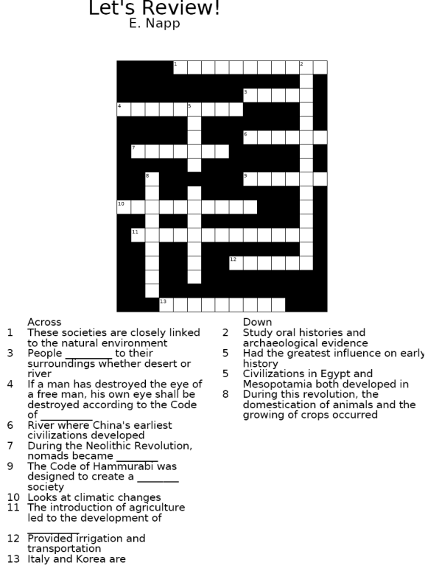

**Word Bank: Anthropologists, Traditional, Adapt, River Valleys, Neolithic, Geographer, Stable, Hammurabi, Farmers, Rivers, Peninsula, Civilizations, Yellow**

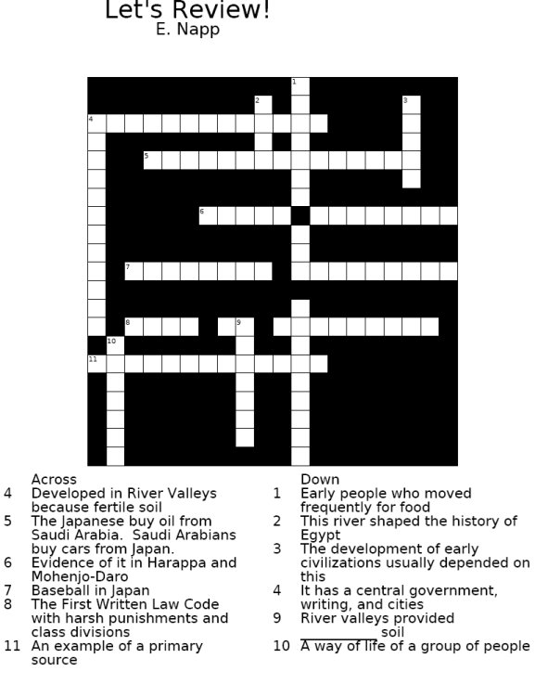

**Word Bank:**

**Hunters and Gatherers, Nile, Autobiography, Code of Hammurabi, Interdependence, Fertile, Culture, Cultural Diffusion, Rivers, Civilization, Urban Planning, Civilizations**

Unit 2 **A Successful Failure**

**Directions:**

1. **READ the introduction and the story.**
2. **ANNOTATE while you read the introduction AND the story (circle unknown words, underline important phrases, “talk back” by writing your thoughts)**
3. **ANSWER the questions at the end of the reading.**

Talk Back Below!

Julius Caesar named his 18 year old great nephew and adopted son as his heir. Octavian had promised to restore the republic. He replaced most of the members of the Roman Senate with his followers with the lower and middle classes. He offered to give up his dictatorial powers, but the Senate begged him to continue as the all-powerful leader. In 27 B.C.E., he was given the title of Augustus (honored or revered one), and was also called princeps, or first citizen. He was the first emperor of the Roman Empire.

Augustus' decrees (official decisions) had the force of law. He had the legal right and power to do anything he thought was in the best interest of the empire. Augustus controlled Rome's army, its finances (money), and all government jobs.

Augustus was not physically strong and constantly complained of assorted illnesses. Horseback riding tired him, and he could not stand to be out in the sun. Yet his strategies defeated his enemies in battle. As emperor, he ruled fairly and efficiently for many years. Under his leadership, Rome progressed from social upheaval and economic disorder to peace and prosperity (happiness).

In our story, Augustus meets Tiberius (the son of his second wife, Livia), a man he admires but does not love. Tiberius has just returned to Rome from a long exile (to be away from your home) on a remote island.

*"Thank you, Tiberius, for returning to Rome," said Augustus. "I haven't seen you for seven years."*

*"I'm glad to be back," said Tiberius. "I would have returned sooner, but I thought you never wanted to speak to me again."*

*"Nonsense," said the emperor. "It wasn't my fault that you left Rome. Now, I need you. I've been ruling Rome and the empire for thirty years. I must admit that I am no longer able to do the job by myself. I'm tired and I'm sick."*

*"But," said Tiberius, "you must get better soon. There's so much more for you to do."*

*"It's no use. I've failed."*

*"Failed!" snorted Tiberius. "How can you say that? Think of all you have done for Rome. Before you were appointed princeps, Rome was a mess. Thousands of people were out of work. Many more were without food and decent housing. You have given them food and jobs."*

*"We still have unemployment."*

*"Not nearly as much as before," replied Tiberius. "The point is that you never stopped trying to help the needy. You went even further. You gave poor people and retired soldiers farms in the provinces."*

*"Rome was terribly overcrowded," replied Augustus, "but there was much unused land in our distant provinces. Anyone would have done the same."*

*"Not just anyone," replied Tiberius. "Your uncle, Julius Caesar, had similar ideas, but his enemies took his life. As for the others, they did nothing."*

*"I'll never forgive those assassins!"*

*"Wait, there's more. Merchants and travelers were afraid of the robbers on our roads. You provided everyone with safe travel throughout our empire by having the army wipe out the robbers. Great highways now link Rome to far-distant parts of the empire. You encouraged farmers by lending them money without charging interest. There are no restrictions on trade throughout the empire. The value of our money is stable. We have a fine postal system. Rome is a safe place, thanks to the civil guard (police)."*

*"You almost have me believing that I did a fairly good job," smiled Augustus.*

*"Look at all the new buildings and public works that have been constructed in the city - the temples, baths, theaters, public buildings, and roads. You're responsible for all of them."*

*"Tiberius," asked Augustus, "why do you think I asked you to return to Rome?"*

*"I have been waiting for you to tell me," Tiberius replied.*

*"I am a sick man, Tiberius. I need a successor who will be ready to take my place when I die. Therefore, I am going to adopt you as my son and heir," said Augustus.*

*"But why do you choose me?" asked Tiberius.*

*"This is something I should have done years ago. I have always admired you, though I thought you were cool and distant. You are honest, reliable, and dependable. There is no one else I can trust. You will be the emperor of Rome after I die!"*

*"I am surprised and honored," said Tiberius. "What shall I do first?"*

*"Go to Gaul (France) and Germany and end their revolt against Rome!"*

After many battles, Tiberius defeated the Gauls and Germans. In 4 B.C.E., he returned to Rome to be named Augustus's heir. Ten years later, in the year 14, Augustus died, and Tiberius became emperor. With few exceptions, the next 200 years were peaceful ones. The Roman Empire was well run and its boundaries were extended in Europe, England, and the Middle East. At its height, the empire contained 70 million people of many different cultures and languages. Some emperors, such as Augustus and Tiberius, were excellent rulers. Others, such as Nero and Caligula, were unfit for the job. Yet the empire and its people continued to enjoy a high level of prosperity (well-being).

**Questions for Review:**

1. How did Octavian become the first Roman emperor?

____________________________________________________________________________________

2. What powers did Augustus (Octavian) gain when he became emperor?

___________________________________________________________________________________

3. How did Tiberius prove that Augustus was not a failure?

__________________________________________________________________________________

4. Why did Augustus choose Tiberius to replace him?

__________________________________________________________________________________

**Activities:**

3. Prepare an obituary (death notice you might find in a newspaper) for Augustus highlighting the significant events in his life and his achievements.

______________________________________________________________________________________________________________________________________________________________________________________________________________________________________________________________________________________________________________________________________________________________________________________________________________________________________________________________________________________________________________________________________________________________________________

Unit 3

A Monk’s Story

Before Reading:

Central governments were weak during the Middle Ages. Feudal nobles or lords fought with each other for land or glory. The life of a poor person, especially a serf (a person bound to the lord’s land), was worth very little.

While central governments were weak, the Roman Catholic Church was strong. It was well organized and wealthy. Catholics had to pay a tithe or church tax. The Church offered people a proper way of life, a path to follow from birth to death to heaven. Kings and nobles were encouraged to be less cruel. Work was praised and blessed.

It was a blessing to care for poor people, widows, and orphans. Hospitals to heal the sick were opened in many towns. The church or cathedral was the center for everyone. Most villagers were baptized there, and most were buried in the churchyard.

All education and training of the young took place in the church or monastery schools. A monastery was a home or residence for monks or men who are members of a religious order. Art was often brought by villagers to the church to beautify the house of God. Often monks in monasteries were artists in their own right.

In this story, there is a monk in a monastery in the French city of Dijon. A monastery was a place where a man lived away from the problems of life of the rest of the world. Often the rules and regulations of the monastery were strict. The monk promised to follow a life of poverty, chastity, and obedience. The monk gave up everything he owned (poverty), promised never to marry (chastity), and had to obey his superiors (obedience). The monk agreed to obey the rules of his order or group of monks.

Questions:

1. What was weak and what was strong during the Middle Ages or the Medieval Period? __________________________________________________________________________________________________________________________________________________________________________________________________________________________________________

2. Why was one institution weak and the other strong during the Middle Ages or the Medieval Period? __________________________________________________________________________________________________________________________________________________________________________________________________________________________________________

3. Describe life in a monastery. __________________________________________________________________________________________________________________________________________________________________________________________________________________________________________

4. Why would a young man be willing to give up so much and become a monk in the Middle Ages? __________________________________________________________________________________________________________________________________________________________________________________________________________________________________________

A Monk’s Story Dijon, 1131

“At last sunlight comes into my lonely little room. Soon I will leave my cell and join my brother monks in prayer and breakfast. It will be cold outside, but I can’t wait to feel the earth in my hands. My job today will be to pull weeds from the vegetable patch. It is backbreaking work, but I love it. Bend down, dig up the whole weed. Bend and dig, bend and dig; never stop, keep moving. The sun is warm on my head and back. I am out of doors in the sight of God.

“I must keep working, working. I must forget my life in the village. I must forget my friends. Why do I hear their voices? Why can’t I talk to them? What a fool I am? There are no voices. There’s no one here! Six months in this monastery! Six months I have been alone. I am alone with over a hundred brother monks!

“Why can’t I talk to anyone? Why did we vow never to talk to each other unless we get special permission? Is that why I keep hearing voices? No, I know that there are no voices here. God will help me; he will make me strong. I must pray now.

“Why did I come to this monastery? I could have become a knight. Wouldn’t I be more proud to be Sir Denis instead of Brother Denis? No – I hate fighting. I can’t kill anyone. I get sick to my stomach just thinking of blood! Or I could have been a rich merchant. I could have bought and sold anything and everything that rich people want. No – I have no use for money. It means nothing to me.

“Would I be happy as a village priest? I’m not sure. If I had my own church, I could talk to people and work with them. I could help them understand life and death, with the words of God. I see myself giving the blessed sacraments. I baptize, confirm, and marry their children. I give them Holy Communion and the last rites when they die. Yes, I thought about being a priest for a long, long time. But these are troubled times. There is killing and stealing. The weak are pushed around by the strong. The strong are overcome by those who are even stronger! People just don’t seem to care for each other.

“I’m not one of those strong ones. I am not strong enough to push others around. I cannot help poor people because I myself am weak. Yet I want to do God’s work. I know that, if I cannot do it in the outside world, I can help in the monastery. “This is my world. In this monastery I know exactly where I am and what I must do every day. I do what I am supposed to do. There are rules for each hour of the day. Everything is planned for me, but I do have time to think and pray. Here, I will atone (make up) for the sins of my youth.

“I am not lazy or afraid to work. No one wastes time in this monastery. I work hard because it is God’s will. I love my farm work, and I am beginning to enjoy copying Latin and Greek books. My lettering is better now. I am learning to decorate the pages with little drawings. I never thought that I, Brother Denis, could be an artist! Now my life has meaning! This is real! I work at my own pace; I do as much as I can. I will not let myself feel tired! I think only of my work. I help myself, but I am useful to God and to the people.

“There’s the bell for breakfast. O Lord, help me through the day, the months, the years. Help me do your work in this monastery. Help me to stay silent today. I promise I will not say one word – even if another monk speaks to me! Do not let me break any of the rules. I pray that you will help me to forget my life out there in the village. Le my mind be clear of worldly things.”

Questions:

True or False: Write a T or an F next to each statement.

1- During the Middle Ages, central governments were stronger than the Church. __

2- All monks were weak people. _____

3- The Church gave people a path to follow from birth to death to Heaven. ____

4- Church buildings were used only for prayer. _____

5- Brother Denis vowed never to speak without special permission. _____

6- The Catholic Church took no interest in the sick and the poor. _____

7- Brother Denis could not learn to draw pictures in the books he copied. _____

8- All monks in the Middle Ages took vows of silence. _____

Do you think Brother Denis made a wise choice when he entered the monastery? Explain your answer. _________________________________________________________________________________________________________________________________________________________________________________________________________________________________________

There are still monasteries in the world today. Would you be willing to join one? Why or why not?

_________________________________________________________________________________________________________________________________________________________________________________________________________________________________________

If Brother Denis were alive today, what other jobs would be open to him? ________________________________________________________________________________________________________________________________________________

Unit 4

The Great Artists and Philosophers of the Renaissance

Leonardo da Vinci:

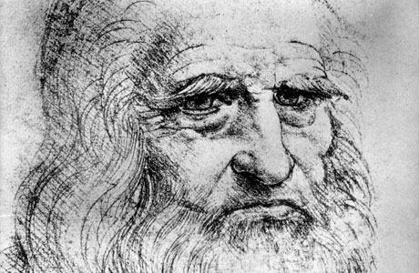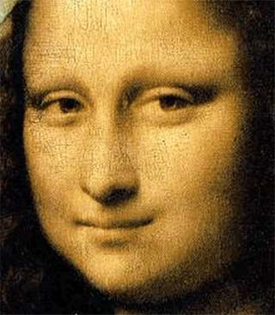

Leonardo da Vinci was a true Renaissance man. Born in the small Italian village of Vinci in 1452, da Vinci had many interests and much skill. Leonardo became an artist, scientist, engineer, and inventor. In 1503, Leonardo completed his most famous painting, the ***Mona Lisa***. Another important painting was Leonardo’s ***Last Supper***. As a scientist, Leonardo drew natural objects and in dozens of notebooks recorded what he saw. He even dissected dead human bodies for study. In his notebooks, he also drew a bicycle, canon, machine gun, submarine, flying machine, and even a parachute long before these items were ever invented.

Michelangelo:

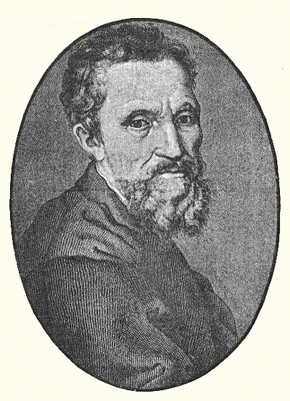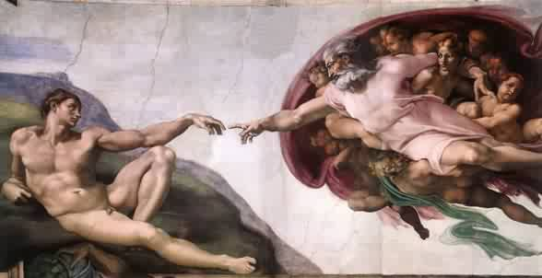

Michelangelo was born near Florence in 1475. At the age of 23, he became famous as a sculptor for his carving the ***Pieta***. The sculpture shows Mary, the mother of Jesus, holding his dead body. Michelangelo also completed a statue of David. When he was thirty-three, the pope asked him to paint the ceiling of the Sistine Chapel in the Vatican. Michelangelo insisted that he was a sculptor and not a painter but the pope would not take no for an answer. Michelangelo painted the ceiling while lying on his back, 80 feet above the floor. It took four years to complete. He painted more than 300 people and pictures on the ceiling.

Perspective in Art: A Lesson from the Renaissance

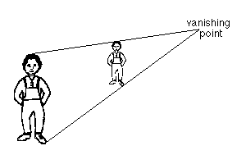

Machiavelli:

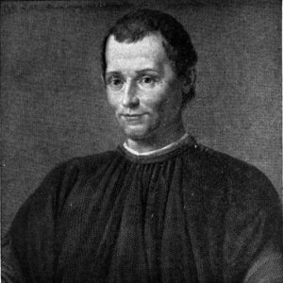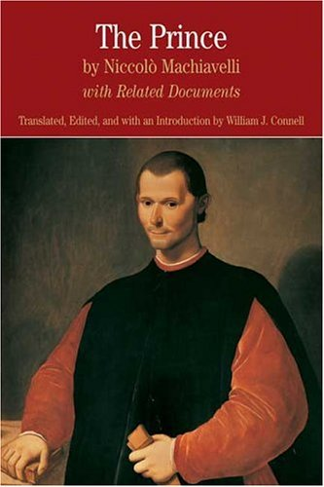

Machiavelli was a famous writer and historian. He had a job as a secretary to a government council that traveled throughout Italy. During these trips, Machiavelli met many rulers. He wondered how they got and kept power. As a result, he watched how they acted.

Based on what he saw, Machiavelli set up his own ideas about how to rule. He stated them in a book titled ***The Prince***. He believed that for a ruler, the ends justify the means. In other words, the usual rules for behavior do not apply to rulers. Rulers must do whatever is necessary to maintain power. Machiavelli believed that rulers should focus on power and success only.

More Highlights of the Renaissance:

William Shakespeare:

The ideas of the Renaissance eventually spread to other regions. William Shakespeare wrote many plays whose popularity has endured for centuries. His dramas include ***Hamlet***, ***Macbeth***, and ***Romeo and Juliet***. He explored the full range of human activities and emotions. He was another great artist of the Renaissance.

Galileo Galilei:

Galileo Galilei rejected reliance on authorities and developed a more scientific method, which emphasized direct observation, measurement, and experimentation. This great Renaissance scientist challenged the Roman Catholic Church when he supported Nicholas Copernicus’ thesis that the earth and the other planets revolved around the sun. This contradicted Church teachings which stated that the earth was the center of the universe. Of course, Copernicus and Galileo were correct!

Miguel de Cervantes:

Another leading writer of the Renaissance was Miguel de Cervantes, a Spanish writer. He created the wonderful character of Don Quixote. Cervantes published the first part of his novel, ***Don Quixote de la Mancha***, in 1605. Quixote sees himself as a knight who must right the wrongs of the world. With his servant, Sancho Panza, he rides throughout Spain. They have one adventure after another. Don Quixote is a comic character. People have loved Don Quixote for over 400 years. Thanks to the creation of moveable type, a printing press, developed by Johann Gutenberg in the 1400s, books became more readily available.

Questions from yesterday and today:

1: What was the Renaissance? ____________________________________________________________________________________________________________________________________________________________

2: Define humanism. ____________________________________________________________________________________________________________________________________________________________

3. Define secularism. ____________________________________________________________________________________________________________________________________________________________

4. Where, when and why did the Renaissance begin? ____________________________________________________________________________________________________________________________________________________________

5. Who did Renaissance thinkers study? Why? ____________________________________________________________________________________________________________________________________________________________

6. Who was Machiavelli and why was he important? ____________________________________________________________________________________________________________________________________________________________

7. Do you agree or disagree with Machiavelli? Explain your answer. ____________________________________________________________________________________________________________________________________________________________

8. Who was Leonardo da Vinci and what were his accomplishments? ____________________________________________________________________________________________________________________________________________________________

9. What is perspective in art? ____________________________________________________________________________________________________________________________________________________________

10. Who was Michelangelo and what were his accomplishments? ____________________________________________________________________________________________________________________________________________________________

11. Why did Galileo Galilei get in trouble with the Roman Catholic Church? ____________________________________________________________________________________________________________________________________________________________

12. Why did the scientific method often lead to conflict with the Roman Catholic Church? __________________________________________________________________________________________________________________________________________________________

14. Who invented moveable type and the printing press? How did this invention change world history? ___________________________________________________________________________________________________________________________________________________________

15. Who was William Shakespeare and why is he considered a great Renaissance writer? ___________________________________________________________________________________________________________________________________________________________

Unit 5

Unit 5 Study Guide

1. What were some of the **positive** effects of the Columbian Exchange? **Negative** effects? __________________________________________________________________________________________________________________________________________________________________________________________________________________________________________

2. Which **country began** the European Age of Exploration? ____________________

3. Why did some Pre-Columbian American civilizations practice **human** **sacrifice**? ____________________________________________________________________________________________________________________________________________________________

4. What were some **reasons** why the greatly outnumbered Spaniards were able to conquer the Aztec and Inca?

____________________________________________________________________________________________________________________________________________________________

5. Give some examples of the **technology** that enabled Europeans to explore overseas. ____________________________________________________________________________________________________________________________________________________________

6. Name **three trade routes** that existed before the European Age of Exploration. __________________________________________________________________________________________________________________________________________________________________________________________________________________________________________

7. Which medieval **West African city** was known as a learning and cultural center? ____________________________________________________________________________________________________________________________________________________________

8. Why were **Ghana, Mali, and Songhai** able to become **wealthy** and **powerful**?

____________________________________________________________________________________________________________________________________________________________

9. How did the Aztecs and Incas each **adapt to their environment** in order to practice agriculture?

____________________________________________________________________________________________________________________________________________________________

10. What is exchanged on trades routes **in addition to goods**? ____________________________________________________________________________________________________________________________________________________________

11. How did the **Inca unify** their huge civilization?

____________________________________________________________________________________________________________________________________________________________

12. **Where** did the majority of the slaves captured come from? Where were the majority of the captives **sent**?

____________________________________________________________________________________________________________________________________________________________

13. According to the mercantilism system, what made a country powerful?

_____________________________________________________________________________________

14. According to mercantilism, how did countries achieve #13?

____________________________________________________________________________________________________________________________________________________________

15. European overseas exploration contributed to the Commercial Revolution and encouraged the growth of what economic system?

____________________________________________________________________________________________________________________________________________________________