Ancient Egypt Cloze  Fill in the blanks with the words in the boxes. |  |  |  |  |  |  |  | 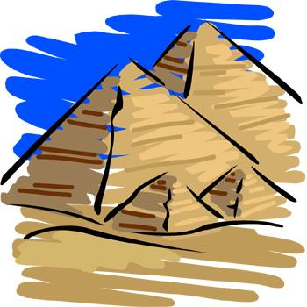
Civilization on the Nile River
transportation |  |  | Desert |  | thousand |  | pyramids |  |  | Nile
Ancient Egyptian civilization, which is famous for its colossal ____________________ began over five ____________________ years ago. It was centered around the ____________________ River and surrounded by the inhospitable Sahara ____________________. The ancient Egyptians depended on the Nile for everything from water to ____________________.
Floods and Irrigation
irrigate |  | tears |  |  | crops |  | flood |  |  | fertile
Though it almost never rains in the Nile River Valley, rains in the far away Ethiopian Highlands cause the Nile River to ____________________ every year. Ancient Egyptians believed that these yearly floods were caused by the ____________________ of the goddess Isis. The floods carried rich soil with them, covering the Nile Delta with ____________________ soil for growing ____________________. Ancient Egyptians created an elaborate system of ditches and canals to _________________ their crops with the flood waters.
Pharaohs
tombs |  |  |  | pharaohs |  | crown |  |  | Great House
The ancient Egyptians were ruled by the ____________________, a title that means ____________________. The pharaohs wore a double ___________________, which represented their rule over Upper and Lower Egypt. When the pharaohs died they were buried in elaborate ___________________.
Egyptian Writing
walls |  |  |  | scribes |  | picture |  |  | papyrus
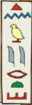 | Ancient Egyptians developed a system of ____________________ writing called hieroglyphics. Ancient Egyptians recorded their beliefs using hieroglyphics on temple and tomb ____________________. They also wrote on scrolls made from ____________________. People who could write were important government officials called ____________________.
©2008 www.bogglesworldesl.com

