Ancient Greece
Directions: Put an X over the 3 boxes you will be submitting. This is like tic-tac-toe-so your choices can be horizontal, vertical, or diagonal.
The Greek Gods  Pick one major Greek god/goddess and assemble a facebook page with all the elements | Ancient Greece News Report of the Olympics  Prepare a 2 min. news report on the Olympic games-either ancient or modern | Athens/Sparta recruitment advertisement  Create a recruiting poster for soldiers to join either the army of Athens or Sparta
Ancient Greek Architecture and Art  Design a collage showing examples of Ancient Greek art and architecture. Include two modern buildings | Travel Journal  Prepare a brochure about Ancient Greece to convince a traveler to visit. | Greek History and You  Design a Venn diagram that compares and contrasts Ancient Greece and the democracy of the United States.
Alexander’s Obit  Write 7 sentences, be sure to use Hellenistic, empire and legacy in the obituary. Include a picture on the tombstone. | An Ancient Greek Myth  Write your own myth with an illustration explaining natural phenomenon. | The Greek Leaders  Make an acrostic for 3 famous Greeks(no gods). For each letter, use words or phrases that describe his/her traits

Name: Block:
My Ancient Greece Activity Book
Ancient Greek Language
The Greeks spoke a different language and they have influenced ours with a lot of words.
How many words can you write with these prefixes and suffixes.
A prefix does at the start of the word. A suffix goes at the end of the word.

Geo- -ology
Phot- -phobia
Tech- -graph
Anti- -meter
Bio- -ocracy
Tele- -onym

Greek and Hellenistic Achievements of the Greek civilization
 | Classical Greece | Hellenistic Greece
Arts and architecture
Literature
Science and technology
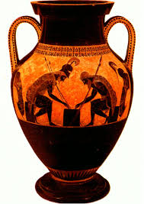Ancient Greek pottery
The ancient Greeks were famous for making pottery. They were allowed to use only two colors: black and orange.
Can you design your own? Use black and orange.
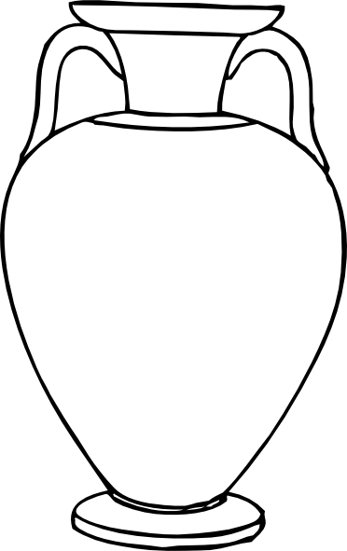
Ancient Greek numbers
The Ancient Greeks used different symbols for their numbers. Use the table to do the work. If you want to write 11 you would write the symbol for 10 and then write the symbol for 1.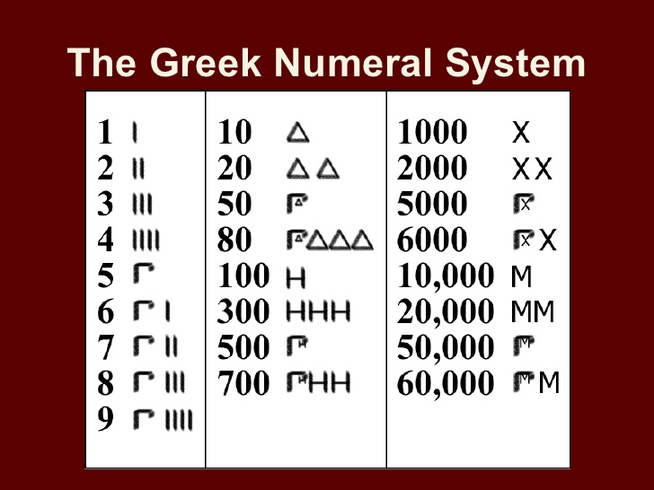
How would you make the number21?_____31?_____35?_______42?_____
Can you find the symbol for 50? Write it down________
Can you work out the answers and write in Ancient Greek?
12x7= 9x9=
82+28= 10x10=
Philosophy
Drama
History
If you had to judge: which is the most important contribution:__________________

The Ancient Greek Olympics
What are the differences between the Ancient Greek Olympics and the Modern Olympic?
 | Ancient Greece | Modern
What year did the Olympics start?
What do the athletes wear?
What events do women take part in?
Which countries competed?
What events are there?

Write a paragraph comparing the differences between the two Olympic games

Ancient Greek Temple
The Greeks loved building temples to worship their gods.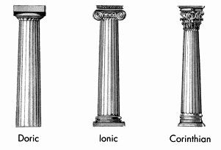
Task-look at the three different types of columns.
Which type is on the building below?
Answer:
What is the name of the most famous temple in Athens?
Answer:
Which goddess was worshiped there?
Answer:
Ancient Greek Mythology
Ancient Greeks explained the world and the natural events around them through myths.
Persephone was Demeter's daughter. Demeter was the goddess of harvest and Persephone was the goddess of springtime. One day, while they were picking flowers, Hades, the lord of the dead, came out of the ground and kidnapped Persephone. Demeter looked everywhere for her. She soon learned that Hades fell in love with Persephone and asked Zeus to help him kidnap her so she could become his bride. Demeter was devastated and started to mourn for weeks. The crops started to wilt and humans couldn't grow crops anymore. Zeus decided to do something about it. He told Hermes to bring back Persephone and to make sure she didn't eat any food from the Underworld. (If you ate food from the Underworld, you had to stay there forever.) Hermes went and fetched Persephone. Before she left, Hades convinced her to eat 6 pomegranate seeds. Hermes made a compromise and said Persephone had to stay in the Underworld as Hades wife for 6 months, one month for every pomegranate seed. That's why there are seasons. In the fall and winter, Persephone goes down into the Underworld and Demeter mourns. In the summer and spring, she comes back and Demeter rejoices
What natural events does the myth try to explain?

