Name:_____________________________________________ Date:_______________ Class:_____________

Content Reading Guide: The Cold War Begins

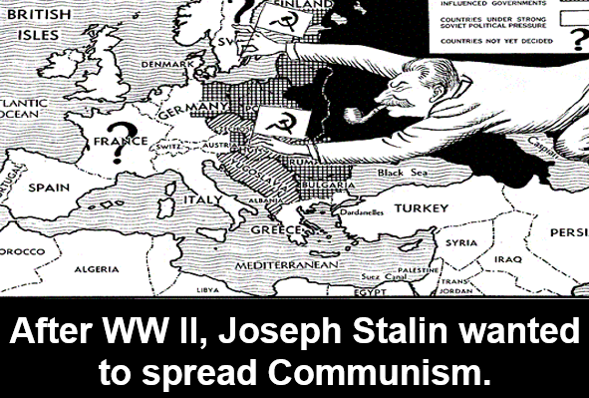
The Democracies of the world had originally teamed up the Communist USSR to defeat Nazi Germany. After the World War II ended, instead of being partners, now the USA stood opposed to the Soviet Union. Harry Truman was President of the USA and Joseph Stalin was still the dictator of the USSR. The USA, France, and Britain wanted elected officials with competing parties in Europe, especially in Germany. The USA tried to keep the Manhattan Project secret from Stalin; this proved the two nations did not really trust each other. There was always tension between the countries.

During and after WW II, many felt that an organization was needed to help prevent future conflicts. In June of 1945, 50 countries signed the UN Charter to try and prevent another world war. This created the United Nations. Woodrow Wilson’s dream of the League of Nations had proven too weak to create change. Yet, the United Nations exists still today as a venue for nations to use diplomacy to address differences and maintain peace. The USA and USSR both tried to utilize the UN to spread their ideas. The USA endorsed Democracy and the USSR endorsed Communism. Truman was concerned about the presence of Communism in Eastern Europe. Yet, the Yalta Conference already stated that the USSR could control Eastern Europe. Many in the USA wanted access to the resources of Eastern Europe for the USA economy. They were concerned that opposition to the USSR’s control of Eastern Europe could create tension in the region. The USSR felt that they had a rightful claim to control Eastern Europe. Their nation lost 20 million people fighting the Nazis; therefore, they felt entitled to control the region.

The USSR created Satellite Nations out of Albania, Bulgaria, Czechoslovakia, Hungary, Poland and Romania.
While technically “independent” nations, these areas were radically controlled by the USSR and practiced Communism. While Stalin had promised FDR that these areas would have free elections, this promise was never fulfilled to the USA. In 1946, George Kennan, an American diplomat, in Moscow, suggested the policy of Containment. This policy would contain Communism and ensure that it spread no further. Containment would prevent Russia from gaining too much power without taking them on in a direct fight. Winston Churchill coined the phrase “iron curtain.” He said an iron curtain now divided Europe. Democracy was in the West and Communism in the East.

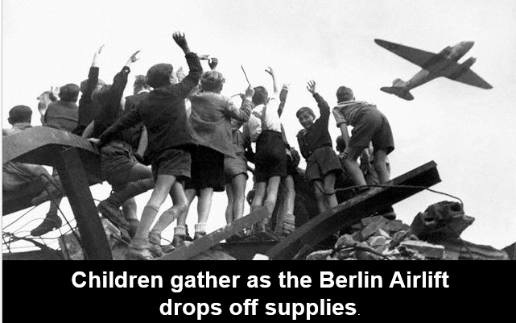
Truman asserted the USA would support any nation that needed help defending itself from Communism, except the Satellite Nations. The USSR controlled these areas. The Marshal Plan stated aid would be given to the war torn nations of Western Europe too. The goal was for these nations to agree that their best interests rested in a Capitalistic / Democratic future. By 1948, the USA, Britain, France combined their German zones; Russia refused to relinquish control of the East. Even though it was in the eastern half, the city area of West Berlin was allowed to be controlled by Democracy. During the Berlin Airlift, West Berlin had food dropped over by the USA, since Stalin cut off supplies to their area. The West wanted to control the western portion of the capital to keep influence in Germany. These efforts gained the allegiance of the people. Food, medicine, fuel, and even toys for children were dropped off in the area. The Berlin Airlift and money being given to various nations caused America’s reputation to increase around the world. The Federal Republic of Germany was born out the 3 zones that were allowed to unite and they formed a Democracy. The Soviet Union called the Eastern half the “German Democratic Republic.” This name was merely propaganda, there was nothing “Democratic” about it.

In 1949, Denmark, Belgium, France, Luxembourg, the Netherlands, Norway, Portugal, Britain, Iceland, Italy, and the USA joined the North Atlantic Treaty Organization. This was a Collective Security. Military support would come to any member country that was attacked. In response, the USSR formed the Warsaw Pact as an alliance ready to strike NATO, if the Soviet Union was attacked.

