Name:_____________________________________________________ Date:____________ Class:_________

Bell Ringer: The Cold War Begins

Instructions: Examine the picture. Read the background information. Answer the questions below.
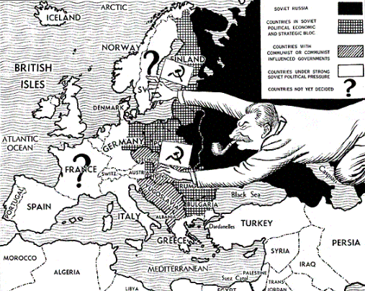
Description: Prior to WW II, the USA feared the Communist takeover of Russia and the rise of the USSR. Yet, when Nazi Germany began to expand, the USSR and the USA had a common enemy in Hitler. They put their differences aside to take down the Nazi Regime. However, when WW II ended, those same tensions flared back up. The USA was concerned that Communism had spread to Eastern Europe and feared it would go further. America desired for the nations of Europe to be ran by their people through Democracy. Stalin wanted to control the region and make it Communist, which would mean it was controlled heavily by government leaders. The USA wanted people to own property and by able to trade through Capitalism. Stalin wanted the economies of Eastern Europe to be controlled by the government with virtually no “private” property, which was a major feature of Communism.

1. Why did the USA and the USSR put aside their differences temporarily in WW II?
______________________________________________________________________________________________________________________________________________________________

2. When WW II ended, what did the USA want for Europe? What did the USSR want for Europe?
______________________________________________________________________________________________________________________________________________________________

3. What is the political difference between Communism and Democracy? What is the economic difference between Capitalism and Communism?
___________________________________________________________________________________________________________________________________________________________________________________________________________________________________________________________________________________________________________________________________________________________________________________________________________
Answers:
1. Why did the USA and the USSR put aside their differences temporarily in WW II?
When Nazi Germany began to expand, the USSR and the USA had a common enemy in Hitler. They put their differences aside to take down the Nazi Regime.

2. When WW II ended, what did the USA want for Europe? What did the USSR want for Europe?
The USA wanted Capitalism and Democracy for Europe. The USSR wanted Communism for Europe.

3. What is the political difference between Communism and Democracy? What is the economic difference between Capitalism and Communism?
In Communism, the government has massive control and there is typically a dictator. In Democracy, the people get to choose their leaders. In Capitalism, people get to own private property and make money off of selling goods and services. In Communism, nobody has private property and the allocation of resources is managed by the government.

